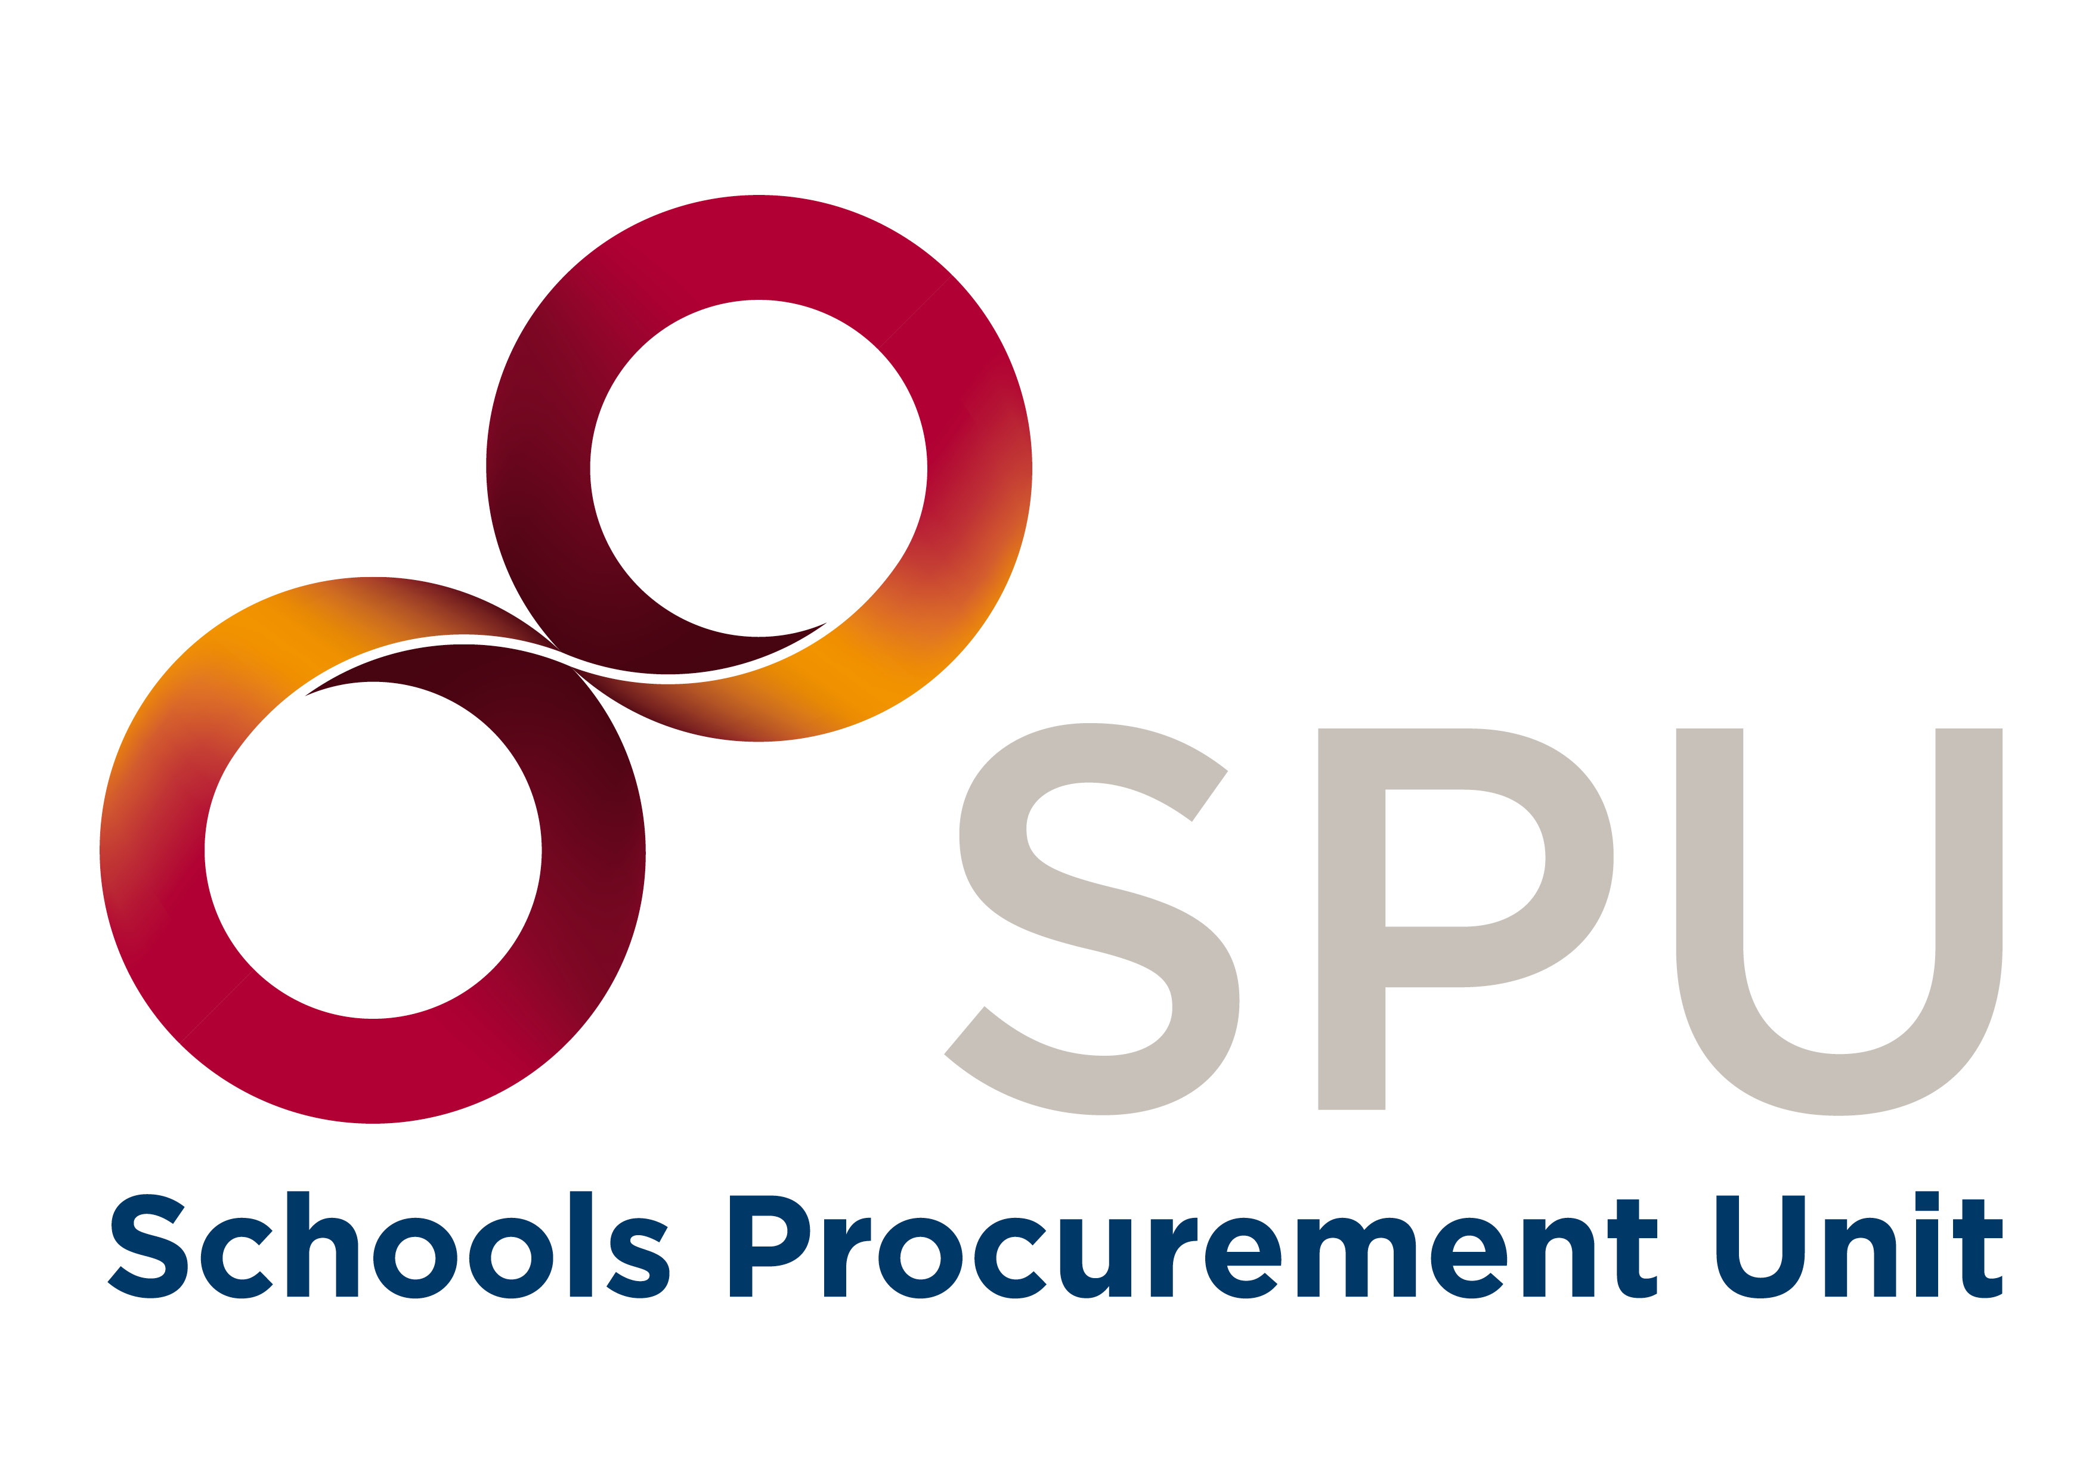 Joint Managerial Body
Secretariat of Secondary Schools
Emmet House,
Milltown,
Dublin 14
D14 V3K8
T: (01) 2838255
F: (01) 202 8219
E: info@jmb.ie
W: www.jmb.ie

Appointment of Clerical Officer in the Schools Procurement Unit
- Introduction
A vacancy exists for a full time Clerical Officer in the Schools Procurement Unit (SPU). The SPU is the central support resource for providing guidance to all primary and post-primary schools (excluding ETB schools) on any procurement related issue. It provides practical advice and help to schools on how to improve their procurement processes and practices on an ongoing basis. It communicates clearly with school personnel, assisting them to access contracts for goods and services which have been negotiated centrally on behalf of schools. The SPU also produces practical guides and regular newsletters to enable schools to meet their obligations under public procurement law, within a complex and changing public procurement environment.

The office of the SPU is based in the JMB/Secretariat of Secondary Schools and grant funded by the Department of Education (DE). The Secretariat of Secondary Schools (SSS) is the employer of SPU personnel, and the SPU Director and staff are answerable to the JMB General Secretary in relation to the day-to-day decision making and running of the unit. The Clerical Officer will be based in the Secretariat of Secondary Schools at Emmet House, Milltown, Dublin 14 and he/she will have access to a hybrid/remote working model subject to the approval of the Board of Directors.

- Role Profile of the SPU Clerical Officer
The Clerical Officer in the SPU will have the following duties and responsibilities:
- Provide close administrative and clerical support for SPU personnel under the direction of the SPU Director;
- Drafting correspondence and other SPU documentation as required;
- Recording minutes from internal and external meetings;
- Assist in the preparation and distribution of media content;
• Assist in the preparation of materials for all SPU presentations and reports;
- Deal with all telephone, email and all other communications involving SPU business;
- Check, examine, record and file all SPU documentation;
- Maintain and update the Customer Relationship Management (CRM) system;
- SPU Website Administrator;
- Maintaining up-to-date information in all databases and records in relation to all schools under the remit of the SPU, including the production of statistics;
- Monitoring the etenders web portal for school activity;
- Placing orders on behalf of the Unit;
- Undertake any specific duties allocated by the SPU Director and/or JMB General Secretary from time to time;
- Manage Social Media content;
- Provide back-up admin support to the JMB Admin Office as required; and
- Data input.

The SPU Clerical Officer will have:
- At least 2 years’ experience working in an administrative/secretarial capacity;
- Excellent IT skills;
- Excellent communication and interpersonal skills;
- An ability to work on their own initiative; and
- Proficiency in the Irish Language would be of advantage for this position.

The working conditions attached to the post of SPU Clerical Officer are as follows:
- Appointment commences in May/June, 2024;
- Probation for six months with the possibility of an extension of this period;
- Contract will be for a three year fixed term, in the first instance;
- Salary will be set at the level of Clerical Officer in the Civil Service. The current weekly scale is €534.34 €567.04 €575.34 €591.55 €615.47 €639.34 €663.20 €680.59 €700.29 €723.17 €739.27 €761.92 €784.42 €819.55 €847.14¹ €859.81²
¹ After 3 years satisfactory service at the maximum.
² After 6 years satisfactory service at the maximum. Entry above the minimum is permitted depending on depth of previous experience demonstrated;
- No pension entitlements other than voluntary access to PRSA;
- The work base will be the JMB Secretariat in Emmet House;
- Working day will be 9.00 a.m. to 5.00 p.m. and
- Opportunities to avail of further training will be provided.

- Core competencies required to successfully carry out the duties of SPU Clerical Officer
- Organisational and Administrative Skills;
- Teamwork skills;
- Commitment to the delivery of high-quality results; and
- Customer Service & Communication Skills.

- Arrangements for Filling the Post:

Application forms and other documentation related to the post are available to download from www.jmb.ie

Completed application forms must be emailed to corporateservices@jmb.ie to arrive no later than Wednesday 17th April 2024. Late applications will not be accepted.

The JMB reserves the right to arrange more than one interview as part of the recruitment process.
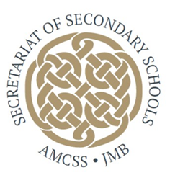Shortlisting may apply. The JMB is an equal opportunities employer.

